Buffalo Urban League

**First-Time Homebuyers Program**

Please call one of our trained counselors to help you find a solution to your housing needs!

(716) 250-2400

Other housing services offered include:

* Fair Housing Assistance
* Housing Location Assistance
* Budget/Credit Counseling
* Mortgage Foreclosure Intervention

Buffalo Urban League

15 Genesee Street

Buffalo, NY 14203

(716) 250-2400

The Buffalo Urban League is a not for profit HUD Certified Counseling Agency

Funding for this program is received from the following:

National Urban League

HUD

City Of Buffalo

United Way

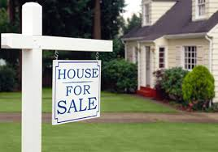

The Buffalo Urban League will be holding its

**First-Time Homebuyer Orientation**

**May 19, 2025**

**6:00 PM – 7:00 PM**

Amherst Town Hall

5583 Main Street

Williamsville, NY 14221

Please call (716) 250-2452 to register.

This is *free* and open to the public.

Learn more about:

* The Process - Where do I start?
* How do I apply for a mortgage?
* Tax benefits of owning a home?
* Credit Repair & Counseling
* Budgeting
* And more!

*Hope to see you there!*

For more information about the services the

Buffalo Urban League provides to our community, please visit

[www.buffalourbanleague.org](http://www.buffalourbanleague.org)

or call 716-250-2400!

***“Empowering Communities, Changing Lives”***